VIETNAM GENERAL CONFEDERATION OF LABOUR

**TON DUC THANG UNIVERSITY**

**FACULTY OF INFORMATION TECHNOLOGY**



**DUONG QUANG THE-519H0350**

**LAM GIA BOI - 520H0519**

**BUGON SHOP**

**FINAL PROJECT**

**MANAGEMENT INFORMATION SYSTEM**

**HO CHI MINH CITY, 2024**

VIETNAM GENERAL CONFEDERATION OF LABOUR

**TON DUC THANG UNIVERSITY**

**FACULTY OF INFORMATION TECHNOLOGY**



**DUONG QUANG THE-519H0350**

**LAM GIA BOI - 520H0519**

**BUGON SHOP**

**FINAL PROJECT**

**MANAGEMENT INFORMATION SYSTEM**

Instructor

**MS. HO THI THANH TUYEN**

**HO CHI MINH CITY, 2024**

# 

# 

# ACKNOWLEDGEMENT

We'd like to thank Ms. Ho Thi Thanh Tuyen for her helpful ideas on how to approach this subject. We have done our best to research this subject. As a result, we hope you can provide your honest opinion about our issue.

*Ho Chi Minh, 12.5.2024*

*Author*

*(Sign and write full name))*

**The**

**Duong Quang The & Lam Gia Boi**

# COMPLETION OF PROJECT AT TON DUC THANG UNIVERSITY

We would like to affirm that this research project is entirely our own work, guided under the academic supervision of Ms.Ho Thi Thanh Tuyen. The contents of this research, along with its results, are truthful and have not been published in any form prior to this. The data presented in the tables and figures used for analysis, observations, and evaluations have been meticulously collected by the author from various sources, which are duly cited in the reference section.

Additionally, this project incorporates some observations, evaluations, as well as data from other authors and organizations. All such references are appropriately cited and sourced.

**Should any form of academic misconduct or impropriety be discovered, we take full responsibility for the content of our project.**Ton Duc Thang University bears no responsibility for any copyright violations or infringements that may have occurred during the course of this research.

*Ho Chi Minh, 12.5.2024*

*Author*

*(Sign and write full name)*

**The**

**Duong Quang The & Lam Gia Boi**

**SUMMARY**

In our subject, my team come up with an imaginary company that we need to manage using mongoDB, express

**TABLE OF CONTENTS**

**ACKNOWLEDGEMENT** **3**

**COMPLETION OF PROJECT AT TON DUC THANG UNIVERSITY** **4**

**LIST OF ILLUSTRATIONS** **9**

**CHAPTER 1. ABOUT THE ORGANIZATION YOU APPROACHED** **9**

1.1 Objectives and mission 9

1.2 Size and organization chart 10

1.3 Overall Business Function 10

**CHAPTER 2. ANALYZE YOUR EXISTING INFORMATION SYSTEM** **11**

2.1 Analyze the industry structure and target market share pursued by the organization. 11

Euromonitor research shows that the F&B chain market in Vietnam is about 1.3 billion USD/year. 12

The three coffee chains leading the market share, Highlands Coffee, Phuc Long and Starbucks, have opened more than 1,000 points of sale. 13

Figure 2.2 Market share of major competitors 13

Porter’s 5 forces model: 13

2.2 Competitive strategy of the organization in each period from the present to the next 10 years. 14

Present - 2 Years: 14

1. Quality and Consistency: Focus on delivering high-quality coffee and maintaining consistency in taste and service. 14

2. Customer Experience: Enhance the in-store experience with comfortable seating, ambient music, and friendly staff. 14

3. Digital Presence: Strengthen the online presence through social media engagement, online ordering, and a user-friendly website. 14

4. Local Community Engagement: Participate in local events, collaborate with nearby businesses, and support community initiatives to build a loyal customer base. 14

2 - 5 Years: 14

1. Expansion: Explore opportunities for expansion, either by opening new locations in high-traffic areas or through franchising. 14

2. Menu Diversification: Introduce new coffee blends, specialty drinks, and food items to cater to diverse customer preferences. 14

3. Sustainability Initiatives: Implement environmentally friendly practices such as using compostable packaging, sourcing ethically traded coffee beans, and reducing waste. 14

4. Technology Integration: Invest in technology solutions such as mobile ordering apps, loyalty programs, and contactless payment options to enhance convenience for customers. 14

5 - 8 Years: 15

1. Market Differentiation: Differentiate the brand by focusing on a specific niche such as organic coffee, fair-trade sourcing, or unique brewing methods. 15

2. Global Expansion: Consider expanding internationally to tap into new markets and diversify revenue streams. 15

3. Partnerships and Collaborations: Form strategic partnerships with other businesses, influencers, or organizations to reach new audiences and strengthen brand positioning. 15

4. Customer Data Utilization: Leverage customer data to personalize marketing efforts, improve product offerings, and enhance the overall customer experience. 15

8 - 10 Years: 15

1. Innovation Hub: Establish an innovation hub to research and develop new products, technologies, and business models to stay ahead of competitors. 15

2. Vertical Integration: Explore opportunities for vertical integration by owning coffee bean farms, roasting facilities, or distribution channels to have more control over the supply chain and ensure quality. 15

3. Corporate Social Responsibility: Deepen the commitment to corporate social responsibility by supporting social causes, investing in employee welfare, and minimizing environmental impact. 15

4. Continuous Improvement: Maintain a culture of continuous improvement by soliciting feedback from customers and employees, conducting regular performance reviews, and adapting to changing market trends. 16

2.3 Value chain of the system, identify and analyze the main activities/support activities in the value chain that you consider most. 16

Support activities: 18

2.4 Analyze organization structure of 5 components of an information system: hardware, software, people, processes, and data. 19

Figure 2.3 Process 21

**CHAPTER 3. ORGANIZATIONAL ISSUES** **21**

3.1 Indicate the existing problems of the old system and the expected goals of the new system 21

3.2 Clearly analyze in which components/structures of the system these problems arise. 22

**CHAPTER 4. Proposal of a new system** **24**

4.1 General use case diagram, ERD 24

Figure 4.1 Use Case Diagram 25

Figure 4.2 Class Diagram 26

Figure 4.3 ER Diagram 27

4.2 Describe the changed/improved processes/techniques of the new system and analyze and evaluate what new changes/proposals meet/support for the organization’s competitive strategy 27

Identify ethical and privacy issues related to the data the system collects. Provide solutions to solve these problems 28

Ethical and Privacy Issues: 28

**CHAPTER 5. EVALUATION, CONCLUSION** **30**

5.1 Pros and Cons 30

5.2 Review 30

**REFERENCES** **31**

# LIST OF ILLUSTRATIONS

# ABOUT THE ORGANIZATION YOU APPROACHED

## Objectives and mission

* Main business: F&B(Food and Beverage Service) Tea & Coffee Shop
* Establish in April 2024
* Headquarters: HCM City, Viet Nam
* Company Logo:

Figure 1.1 Bugon Logo

* Objectives: The Bugon Shop brings a new experience and a good feeling for customers when they come. In order to satisfy our customers' desires and tastes, we serve a wide range of high-quality, soft drinks. Additionally, the distinct taste will give customers a sense of freshness.
* Mission: Our goal is to bring a comfortable, pleasant feeling that satisfies all senses, even the most demanding customers. The comfort and happiness of our customers is our top priority. All employees of the company will be trained to focus on customer satisfaction and be professional to handle problems right after they come out.

First, we aim to create more spaces for people to connect, relax, and enjoy exciting drinks that inspire conversation and fun by opening more branches across the country. Secondly, we focus on making a difference with our own products, which are called “Bugon Cafe." This product made our brand well-known. The last thing is customer retention. We offer many vouchers for discounts or create special events for customers who have membership cards.

## Size and organization chart

* Size: Small (40 Employees)
* Organization Chart:  
  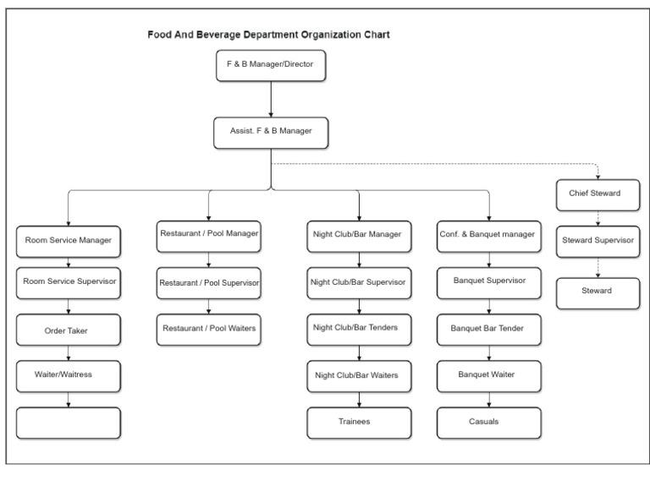

Figure 1.2 Organizational Chart of Cloud Tea

## Overall Business Function

| Functional Area | Business Processes |
| --- | --- |
| Sales and Marketing | Product Promotion, Customer Engagement, Market Research, Branding, Advertising, Customer Service |
| Accounting and Finance | Financial Reporting, Budgeting, Expense Management, Inventory Control, Tax Compliance, Financial Analysis |
| Human Resource | Recruitment and Hiring, Employee Training, Performance Management, Payroll Processing, Employee Relations, Health and Safety |

Table 1.1 Business function

# ANALYZE YOUR EXISTING INFORMATION SYSTEM

## Analyze the industry structure and target market share pursued by the organization.

**Industry structure:** The beverage industry encompasses a wide range of products, including soft drinks, coffee, tea, smoothies, and specialty drinks. The competitive landscape may include large chains, independent cafes, specialty shops, and online delivery services.

**Market segmentation:** Customers in the beverage industry can be segmented based on preferences, demographics and psychographics. Segments include beverage-minded consumers such as coffee enthusiasts, tea enthusiasts, and those seeking unique or artisanal beverages. Besides, there are also people looking for a suitable space to work, chat with friends, or enjoy at a cafe by themselves.

**Target Market Share Pursued:**

**Differentiation Strategy**: The Bugon shop pursues a differentiation strategy by offering unique and innovative beverages not readily available elsewhere. This could include signature drinks, custom blends, or specialty ingredients.

**Target Market Segments:** Bugon shop targets a group of young customers (from 18 to 30 years old) who like to experience new flavors, especially the mix of Baileys milk wine with a hint of coffee shop flavor. This is a potential customer group because young people in our country are always willing to spend large amounts of money on food and beverage services. Besides, everyone over the age of 23 can be financially independent, which is the main source of income for the shop. They care about many aspects of the drink, such as taste, appearance, and service, that can satisfy their needs, which is also the goal we have set.

## Euromonitor research shows that the F&B chain market in Vietnam is about 1.3 billion USD/year.

Figure 2.1 Revenue of drinks served at the store/person/year(USD)

## The three coffee chains leading the market share, Highlands Coffee, Phuc Long and Starbucks, have opened more than 1,000 points of sale.

## Figure 2.2 Market share of major competitors

## Porter’s 5 forces model:

| Traditional competitors | Strong presence and reputation |
| --- | --- |
| New market entrants | Need huge budget to establish |
| Substitute product and Service | New kind of drinks and trends |
| Customers | Price sensitive, easily influence by the media and new trend |
| Suppliers | Influenced by site owners and raw material suppliers |

## Competitive strategy of the organization in each period from the present to the next 10 years.

## Present - 2 Years:

## 1. Quality and Consistency: Focus on delivering high-quality coffee and maintaining consistency in taste and service.

## 2. Customer Experience: Enhance the in-store experience with comfortable seating, ambient music, and friendly staff.

## 3. Digital Presence: Strengthen the online presence through social media engagement, online ordering, and a user-friendly website.

## 4. Local Community Engagement: Participate in local events, collaborate with nearby businesses, and support community initiatives to build a loyal customer base.

## 2 - 5 Years:

## 1. Expansion: Explore opportunities for expansion, either by opening new locations in high-traffic areas or through franchising.

## 2. Menu Diversification: Introduce new coffee blends, specialty drinks, and food items to cater to diverse customer preferences.

## 3. Sustainability Initiatives: Implement environmentally friendly practices such as using compostable packaging, sourcing ethically traded coffee beans, and reducing waste.

## 4. Technology Integration: Invest in technology solutions such as mobile ordering apps, loyalty programs, and contactless payment options to enhance convenience for customers.

## 5 - 8 Years:

## 1. Market Differentiation: Differentiate the brand by focusing on a specific niche such as organic coffee, fair-trade sourcing, or unique brewing methods.

## 2. Global Expansion: Consider expanding internationally to tap into new markets and diversify revenue streams.

## 3. Partnerships and Collaborations: Form strategic partnerships with other businesses, influencers, or organizations to reach new audiences and strengthen brand positioning.

## 4. Customer Data Utilization: Leverage customer data to personalize marketing efforts, improve product offerings, and enhance the overall customer experience.

## 8 - 10 Years:

## 1. Innovation Hub: Establish an innovation hub to research and develop new products, technologies, and business models to stay ahead of competitors.

## 2. Vertical Integration: Explore opportunities for vertical integration by owning coffee bean farms, roasting facilities, or distribution channels to have more control over the supply chain and ensure quality.

## 3. Corporate Social Responsibility: Deepen the commitment to corporate social responsibility by supporting social causes, investing in employee welfare, and minimizing environmental impact.

## 4. Continuous Improvement: Maintain a culture of continuous improvement by soliciting feedback from customers and employees, conducting regular performance reviews, and adapting to changing market trends.

## Value chain of the system, identify and analyze the main activities/support activities in the value chain that you consider most.

**Primary activities:**

1. Inbound Logistics:

- Sourcing Coffee Beans: Procuring high-quality coffee beans from various regions worldwide.

- Inventory Management: Ensuring sufficient stock of coffee beans, milk, syrups, and other ingredients.

2. Operations:

- Brewing Coffee: Brewing coffee using different methods such as espresso machines, pour-over, or French press.

- Food Preparation: Preparing pastries, sandwiches, and other food items.

- Quality Control: Maintaining consistency in taste, temperature, and presentation.

3. Outbound Logistics:

- Order Fulfillment: Serving customers in-store or packaging orders for takeout and delivery.

- Distribution: Managing delivery logistics for wholesale customers or franchise locations.

4. Marketing and Sales:

- Brand Promotion: Marketing the coffee shop through advertising, social media, and promotions.

- Customer Engagement: Interacting with customers, building relationships, and soliciting feedback.

- Sales Management: Managing transactions and implementing loyalty programs.

5. Service:

* **The most important activities in value chains**
* **Customer Experience Management:** Ensuring that customers have a positive and memorable experience when visiting the drink shop. This includes factors such as friendly and attentive customer service, a clean and inviting atmosphere, and efficient order fulfillment.
* **Product Customization:** Offering customization options that allow customers to tailor their drinks to their preferences. This could involve choosing specific ingredients, adjusting sweetness levels, or selecting additional toppings or flavors.
* **Order Accuracy and Timeliness:** Ensuring that orders are prepared accurately and delivered to customers in a timely manner. This involves efficient communication between staff members, proper training on order fulfillment procedures, and utilizing technology to streamline the ordering process.
* **Menu Variety and Innovation:** Continuously updating and diversifying the menu to offer a wide range of beverage options that cater to different tastes and preferences. This could involve introducing seasonal specials, limited-time promotions, or innovative new recipes to keep customers engaged and excited about trying new offerings.
* **Customer Feedback and Improvement:** Actively soliciting feedback from customers to understand their preferences, identify areas for improvement, and implement changes to enhance the overall service experience. This could involve collecting feedback through surveys, social media channels, or direct interactions with customers, and using this information to make informed decisions about menu offerings, operational processes, and customer service practices.

## **Support activities:**

**1. Procurement:**

- Supplier Management: Building relationships with coffee bean suppliers, equipment manufacturers, and other vendors.

- Negotiation: Negotiating prices, terms, and contracts to optimize procurement costs.

**2. Technology Development:**

- Equipment Innovation: Researching and adopting new coffee brewing equipment and technologies to improve efficiency and quality.

- Digital Solutions: Developing and maintaining mobile apps, online ordering systems, and POS software.

**3. Human Resource Management:**

- Recruitment and Training: Hiring and training skilled baristas and staff to provide exceptional service.

- Employee Engagement: Fostering a positive work culture, incentivizing performance, and ensuring employee satisfaction.

**4. Infrastructure:**

- Store Design and Layout: Designing attractive and functional store layouts to enhance the customer experience.

- Facilities Management: Maintaining equipment, facilities, and cleanliness to meet health and safety standards.

## Analyze organization structure of 5 components of an information system: hardware, software, people, processes, and data.

**2.4.1 Hardware**

Technology application is necessary for business development in the present day of rapid technological development.

Implementation: The coffee shop may have an IT department or outsource IT services responsible for selecting, installing, maintaining, and upgrading hardware equipment. This department may collaborate closely with other departments to ensure that hardware supports operational needs efficiently.

Example: PosApp D3 Machine, camera, The server announces the card, Fingerprint machine,..

**2.4.2 Software**

Organizational Structure: The software component includes POS software, inventory management systems, employee scheduling software, customer relationship management (CRM) systems, and possibly mobile apps or online ordering platforms.

Implementation: The IT department or external vendors are responsible for selecting, customizing, implementing, and maintaining software solutions. This involves software licensing, configuration, customization, and regular updates to ensure optimal performance.

Example: MISA CukCuk cafe management software, Loyverse POS software,...

**2.4.3 People**

Organizational Structure: People are the employees working at different levels and roles within the coffee shop, including baristas, managers, waiters, IT specialists, customer service representatives, and administrative staff.

Implementation: The coffee shop has a hierarchical organizational structure, with clear lines of authority and responsibility. Roles and responsibilities are defined, and employees are trained to perform their tasks efficiently.

**2.4.4 Data**

Organizational Structure: Data refers to information collected, stored, and utilized within the coffee shop, including customer profiles, sales data, inventory levels, employee records, and financial transactions.

Implementation: The coffee shop implements data management practices to collect, store, analyze, and utilize data effectively. This may involve the use of databases, data analytics tools, and reporting systems.

**2.4.5 Processes**

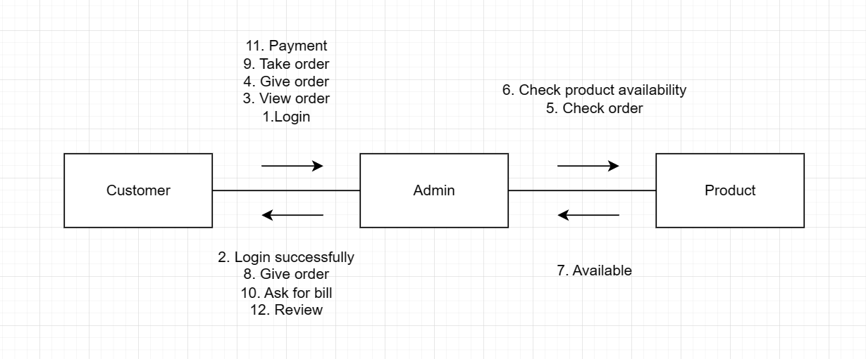

## Figure 2.3 Process

# ORGANIZATIONAL ISSUES

## Indicate the existing problems of the old system and the expected goals of the new system

**3.1.1 Existing Problems of the Old System:**

**Inefficiency in Order Processing:** The old system may suffer from inefficiencies in order processing, leading to long wait times for customers, especially during peak hours.

**Manual Payment Handling:** Handling payments manually can lead to errors in calculation, delays in processing, and potential security risks associated with cash handling.

**Limited Customer Engagement:** The old system may lack mechanisms for engaging with customers beyond the point of sale, such as collecting feedback, building customer profiles, or offering personalized promotions.

**Poor Inventory Management:** Manual inventory management processes may result in inaccuracies in stock levels, leading to stockouts or excess inventory, impacting both customer satisfaction and profitability.

**Lack of Data Analysis:** Without proper systems in place, the old system may not capture sufficient data for analysis, hindering the ability to make informed decisions about menu offerings, pricing strategies, and marketing campaigns.

**3.1.2 Expected Goals of the New System:**

1. **Streamlined Ordering Process**: Implementing a new system to streamline the ordering process, reduce wait times, and improve overall efficiency in serving customers.
2. **Automated Payment Handling**: Introducing automated payment processing solutions to ensure accuracy, speed, and security in handling transactions, including cashless payment options.
3. **Enhanced Customer Engagement:** Implementing customer relationship management (CRM) tools to capture customer data, personalize interactions, and foster long-term relationships through targeted marketing efforts and loyalty programs.
4. **Improved Inventory Management:** Introducing inventory management software to optimize stock levels, track product movement, and minimize waste, ultimately reducing costs and improving inventory turnover rates.
5. **Data-driven Decision Making:** Leveraging data analytics tools to gather insights from customer behavior, sales trends, and operational performance, enabling data-driven decision-making to drive business growth and profitability.

## Clearly analyze in which components/structures of the system these problems arise.

**3.2.1 Expected Goals of the New System:**

**Order Management System:**

Component: Process

Explanation: The Order Management System is a process component as it involves the systematic handling of customer orders from the point of entry to fulfillment. It includes order entry, processing, tracking, and fulfillment processes.

**Payment Processing System:**

Component: Software

Explanation: The Payment Processing System is a software component as it comprises the software applications and platforms used to facilitate payment transactions, including point-of-sale (POS) systems, payment gateways, and payment processing software.

**Customer Relationship Management (CRM) System:**

Component: Software

Explanation: The CRM System is a software component as it consists of software applications and tools used to manage customer interactions, track customer data, and facilitate customer engagement and relationship-building activities.

**Inventory Management System:**

Component: Data, Software, Process

Explanation: The Inventory Management System involves multiple components:

Data: It includes the data component as it involves the storage and management of inventory-related data, such as stock levels, product details, and supplier information.

Software: It involves software components such as inventory management software or systems used to automate inventory-related tasks and processes.

Process: It involves process components related to inventory handling, including stock replenishment, inventory tracking, and order fulfillment processes.

**Business Intelligence (BI) and Analytics System:**

Component: Data, Software, Process, People

Explanation: The BI and Analytics System encompasses various components:

Data: It involves the data component as it relies on data sources from various systems and databases for analysis.

Software: It includes software components such as BI tools, analytics platforms, and reporting software used to analyze data and generate insights.

Process: It involves process components related to data analysis, including data collection, cleansing, modeling, analysis, and reporting processes.

People: It involves people components as it requires skilled analysts, data scientists, and business users to interpret data and make informed decisions based on insights generated from analytics.

# Proposal of a new system

## General use case diagram, ERD

**Use Case Diagram:**

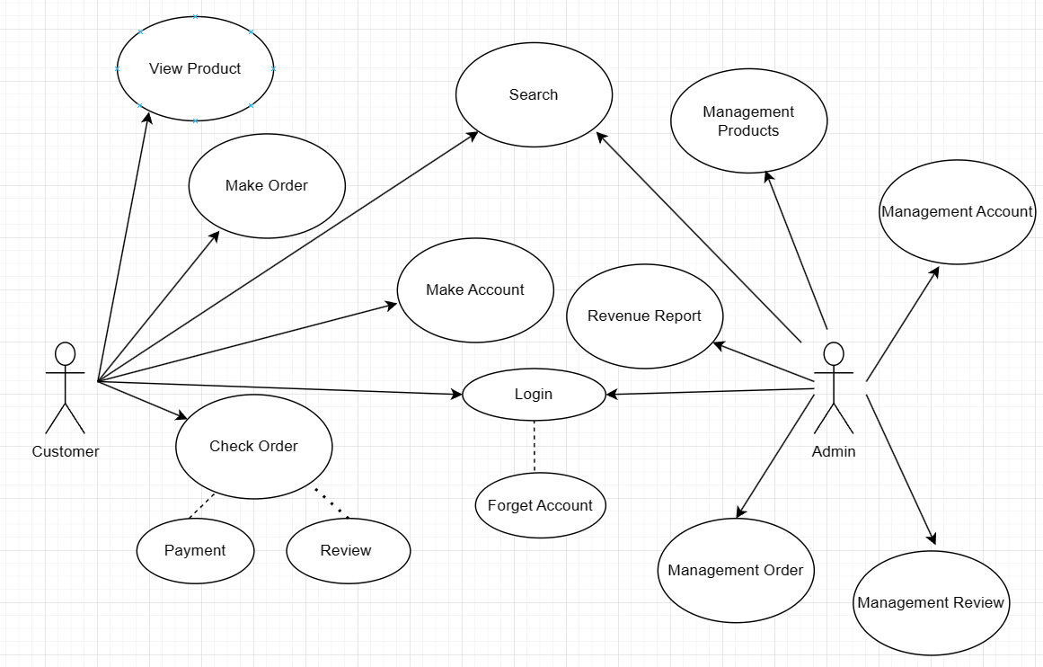

## Figure 4.1 Use Case Diagram

**Class Diagram:**

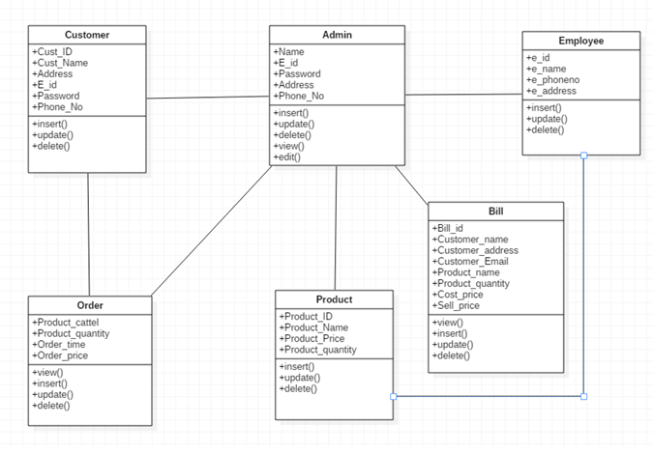

## Figure 4.2 Class Diagram

**ERD:**

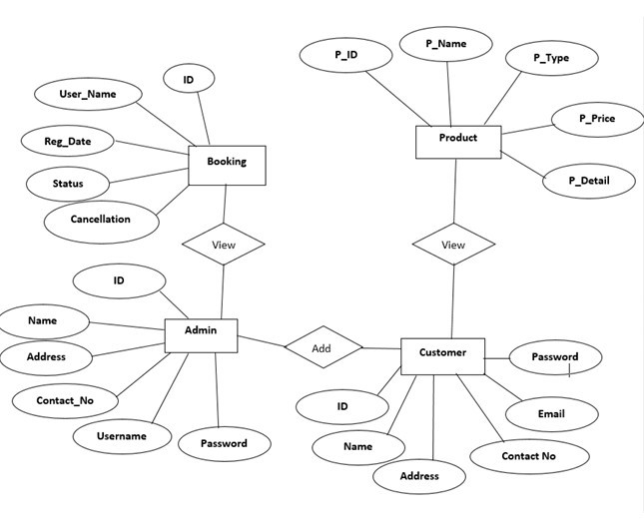

## Figure 4.3 ER Diagram

## Describe the changed/improved processes/techniques of the new system and analyze and evaluate what new changes/proposals meet/support for the organization’s competitive strategy

1. Digital Ordering and Payment:

- Change/Improvement: Implementing a mobile app or online ordering platform for customers to place orders and make payments digitally.

- Analysis: This change enhances convenience for customers, reduces wait times, and enables contactless transactions, which aligns with the competitive strategy of enhancing customer experience and leveraging technology to stay ahead of competitors.

2. Predictive Inventory Management:

- Change/Improvement: Utilizing predictive analytics to forecast demand and optimize inventory levels for coffee beans, milk, syrups, and other ingredients.

- Analysis: By minimizing stockouts and excess inventory, this improvement reduces costs, improves operational efficiency, and ensures product availability, supporting the competitive strategy of cost leadership and operational excellence.

3. Employee Training and Empowerment:

- Change/Improvement: Implementing comprehensive training programs for employees to enhance their coffee-making skills, product knowledge, and customer service abilities. Empowering employees to make decisions and resolve issues autonomously.

- Analysis: Well-trained and empowered employees deliver better service, improve customer satisfaction, and contribute to a positive brand image. This supports the competitive strategy of delivering superior customer service and differentiating the coffee shop from competitors.

## Identify ethical and privacy issues related to the data the system collects. Provide solutions to solve these problems

### Ethical and Privacy Issues:

**Collection of Personally Identifiable Information (PII):**

Issue: Collecting customer data such as names, contact details, or payment information without proper consent can infringe on privacy rights.

Solution: Implement clear and transparent privacy policies outlining what data is collected, how it's used, and obtain explicit consent from customers before collecting any PII. Utilize encryption methods to secure sensitive data.

**Data Security Breaches:**

Issue: Poor data security measures can lead to unauthorized access, data breaches, and exposure of sensitive customer information.

Solution: Employ robust cybersecurity measures, such as encryption, access controls, and regular security audits, to protect customer data from breaches. Ensure compliance with data protection regulations like GDPR or CCPA.

**Data Misuse and Unauthorized Access:**

Issue: Employees or third parties accessing customer data without authorization for personal gain or malicious purposes.

Solution: Implement strict access controls and role-based permissions to limit access to sensitive data. Conduct regular training sessions to educate employees on data privacy policies and the consequences of data misuse.

**Data Retention and Storage:**

Issue: Keeping customer data longer than necessary or storing it insecurely can increase the risk of data breaches and unauthorized access.

Solution: Establish data retention policies specifying how long customer data will be retained and for what purposes. Regularly review and securely dispose of outdated or unnecessary data to minimize risks.

**Lack of Transparency and Consent:**

Issue: Customers may not be aware of how their data is collected, used, or shared by the system, leading to a lack of trust and transparency.

Solution: Provide clear and concise privacy notices and consent forms explaining the purposes of data collection, use, and sharing practices. Allow customers to opt-in or opt-out of data collection and marketing communications.

# EVALUATION, CONCLUSION

## Pros and Cons

Pros: Convenient, easy to use, professionalization process.

Cons: Costly, time consumer to make

## Review

**Ethical and Privacy Measures:**

Implementing privacy by design principles, data minimization strategies, anonymization and pseudonymization techniques, and user-controlled consent mechanisms can enhance data privacy and mitigate ethical risks.

**Training and Awareness:**

Regular training sessions and awareness programs for employees are crucial to ensure compliance with privacy policies, raise awareness about data privacy issues, and foster a culture of responsible data handling.

**Stakeholder Engagement:**

Engaging with stakeholders, including customers, employees, and regulatory authorities, to solicit feedback, address concerns, and demonstrate a commitment to ethical data practices is essential for maintaining trust and accountability.

# REFERENCES

1. [Doanh nghiệp nào đang dẫn đầu thị trường trà - cà phê tỷ đô của Việt Nam? | Báo Nghệ An điện tử (baonghean.vn)](https://baonghean.vn/doanh-nghiep-nao-dang-dan-dau-thi-truong-tra-ca-phe-ty-do-cua-viet-nam-post262576.html)
2. [Cuộc đua bành trướng thị trường của các thương hiệu cà phê và trà sữa - Tạp chí Kinh tế Sài Gòn (thesaigontimes.vn)](https://thesaigontimes.vn/cuoc-dua-banh-truong-thi-truong-cua-cac-thuong-hieu-ca-phe-va-tra-sua/)
3. [Data Analysis: Opening a Coffee shop in Ho Chi Minh City (linkedin.com)](https://www.linkedin.com/pulse/data-analysis-opening-coffee-shop-ho-chi-minh-city-quang-trinh-quoc)
4. [Thị trường cà phê Việt Nam-Chia sẻ, báo cáo-Quy mô ngành (mordorintelligence.com)](https://www.mordorintelligence.com/vi/industry-reports/vietnam-coffee-market)